Recomendation and insights :

-----------------------------------------STORE ANALYTICS ------------------------

TOP 10 STORES WHO CARRIED OUT IR : 2 FROM MYSURU , 4 BENGALURU, 4 CHENNAI

BOTTOM 10 STORES ACCORDING TO ISU FROM :mangalore , visakhapatnam, trivendrum,vijayawada

so for focusing on perticular performance which store is good interms of two factor we have IR , ISU

RECOMMENDATION NUMBER 1:HOW ISU WILL CHANGE THE IR

BUT , WE CALCULATE HOW PER UNIT IR THEN WE HAVE IDEA THAT HOW MY EACH ONE ISU CREMENT WILL GIVE ME IR

IN TERMS OF

ISU ORDER SIS THERE

BENGLARU

CHENNAI

HYDRABAD

COIMBATORE

MYSURU

BUT WHICH CITY DRIVE MORE IR

BENGLARU

CHENNAI

HYDRABAD

MYSURU

COIMBATORE

----------------PROMOTION TYPE ------

WE CLUSTERED PROMOTYPE IN THREE CATEGORY

BOGOF

CASHBACK

DISCOUNT

IF YOU FOCUSING IN IR THEN CASHBACK IS VERY EFFECTIVE TO EARN MORE IR

IF YOUR INVENTORY IS STAGNANT AND YOU WANT TO REDUCE INVENTORY AND ALSO WANT TO INCRESE REVENUE THEN YOU SHOULD RUN BOGOF   
 OTHER DISCOUNT BASED PROMOTION IS NOT WORKING WELL   
  
  
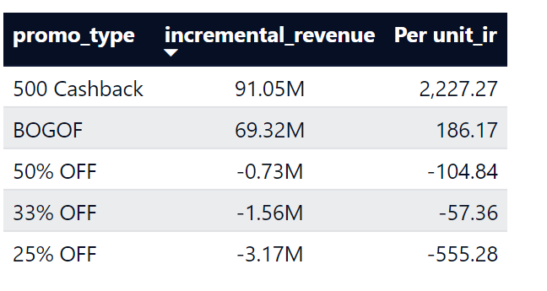  
  
  
we have to think about what type of products are you giving 500 cashbacks that driving more revenue generation   
  
  
which type of product we need to target other promo type so that we can drive more revenue  
  
  
  
---------------------------------------- product and category analytics --------------------------------  
  
 AS PER IR  
  
  
AS PER ISU   
  
BOGOF WILL WORK VERY WELL ACROSS GROCESSORY &STAPLES, HOME ,HOME CARE  
  
CASHBACK WILL WORK VERY WELL ON COMBO 1  
  
FOR PERSONAL CARE CATEGORY WE NEED TO TRY DIFFERENT PROMOTION STRATEGY FOR THAT DISCOUNT BASED PRAMOTION IS LEAD TO NEGATIVE IR   
  
AS , BASED UPON THIS WE GET TO KNOW THAT PEOPLE ARE NORE SKEPTICAL ABOUT % BASED PRAMOTION RATHER THAN SIMPLE PRAMOTION STRATEGY IS LIKE BOGOF , 500 CASHBACK

-------------------------------------------------------------------Diwali sankrati effects------------------------------------------

Diwali campaign bring108k isu and revenue drive 89 million

89 million breakdown   
bogof carries : 16m

Cashback : 77m

Discount based :-4M

**SO IN Diwali cashback pramotion will work best OVERALL**

while sankrati 334k isu where revenue drive is only 66 million

66 million breakdown  
bogof carries : 53m

Cashback : 15m

Discount based :-2M

**SO IN sankrati BOGOF pramotion will work best OVERALL  
  
  
  
------------------------------------KPI BASED ANALYTICS ---------------------**

**Diwali 24.4 % ISU NUMBER BRING OVER ALL 57.41 % IR**

**SANKRATI 75.6% ISU NUMBER BRING OVER ALL 42.6% IR   
  
  
SO WE CAN DELEVE MORE HOW PER UNIT ISU DRIVE REVENUE ACROSS DIFFERENT PRODUCT CATEFORIES , PRODUCT LEVEL , CAMPAIGN WISE AND WE GET TO KNOW EXACTLY WHICH STRATEGY WILL WORK THAT WAY WE CAN MAXIMIZE REVUNE OF COMPANY AND BASED UPON THE EXISTIONG INVENTORY DATA WE CAN DELVE MORE ANALYTICS LIKE FORECASTING ISU AND IR AND WE CAN ACHIVE COMPANY ‘S GOAL AND TARGET FOR SALES DEPARTMENT**